**Term Website Planning Document**

**Site Purpose:**

The main purpose of the site is to advocate the local business community to stimulate the local economy. It promotes the local businesses by listing brief information about them including contact information and their website, and by displaying their advertisement. The site also keeps the members informed about upcoming events and programs, and it also helps them strengthen the relationships with others through social media such as facebook and Instagram. The members are encouraged to share their stories/ businesses on those sites.

**Target Audience:**

Target audience is a business owner and an entrepreneur who is looking for networking, promoting their businesses/ ideas, and contributing to the local community. Whoever likes to join us is welcomed regardless of their age, gender, race, etc.

**Persona 1:**

Name: Charles Anderson

Occupation: Business owner

Age: 32

Hobby: Outdoor activities/ sports

Reason for visit: He just opened a local sporting goods store, and he needs a help to promote it to a broader customer base. He heard that he could be a member of the chamber of commerce to list the ad of his store and builds strong relationships with other local business owners through the city events. He wanted to get more detailed about information of what he could do and what benefits he could receive from the chamber of commerce.

**Persona 2:**

Name: James Elsher

Occupation: Student pursuing a business degree

Age: 20

Hobby: Jogging, movies, fishing

Reason for visit: He is attending at BYU Idaho and pursuing a business degree. He wants to start his business in Rexburg, but he needs to gain more knowledge about how to open a business, what potential competitors are like, etc. He visits the website to search for any business related events in the city so that he could attend the event to get familiar with other business owners.

**Site Map:**

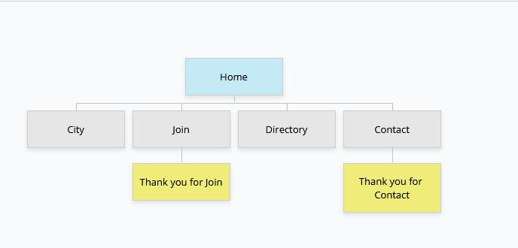

**Color Scheme:**

The color scheme is monochromatic for consistency and unity. I liked the color combination of the water tower in Rexburg, blue and white, so I decided to use different shades of the blue, white, and black for my website.

<https://coolors.co/000000-05098a-2a34f4-8b90f9-ebecfe-ffffff>

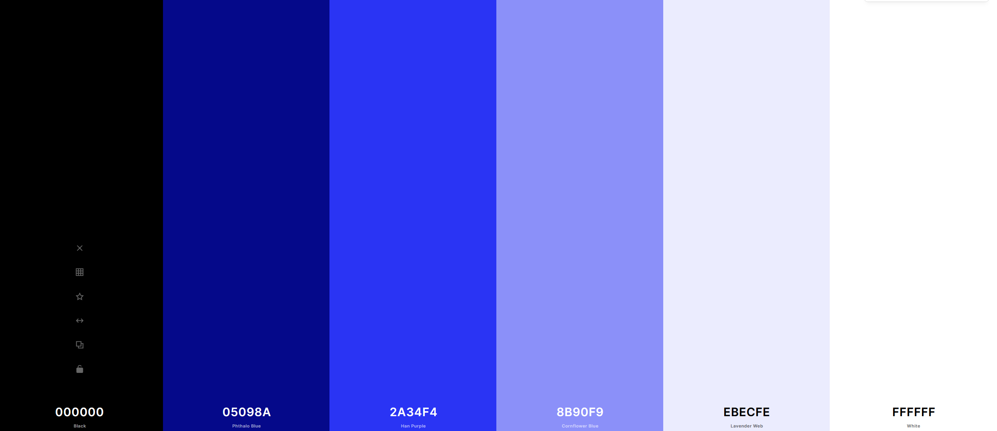

**Typography:**

The primary font for header, navigation, and headings is Open Sans, and the primary font for texts is Lora.

|  |  |  |  |
| --- | --- | --- | --- |
| Site Header | Open Sans | 36px | Sample |
| Primary Navigation | Open Sans | 20px | Sample |
| Footer Navigation | Open Sans | 14px | Sample |
| Heading 1 (h1) | Open Sans | 30px | Sample |
| Heading 2 (h2) | Open Sans | 24px | Sample |
| Paragraph text (p) | Lora | 16px | Sample |

**Wireframes**

Small View (Mobile View)

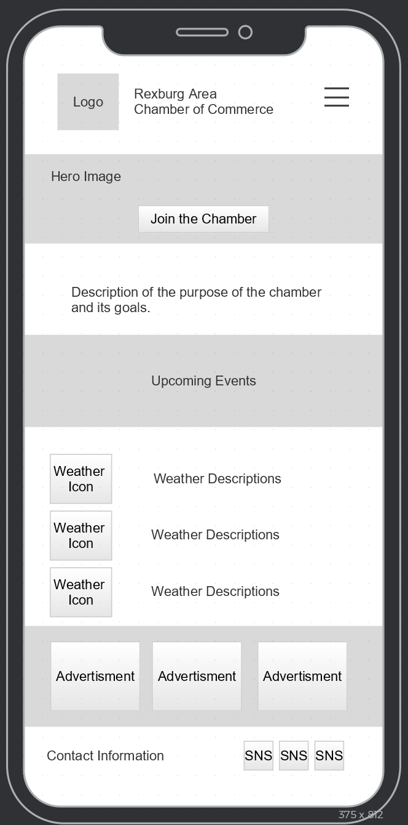

Medium View (Table View)

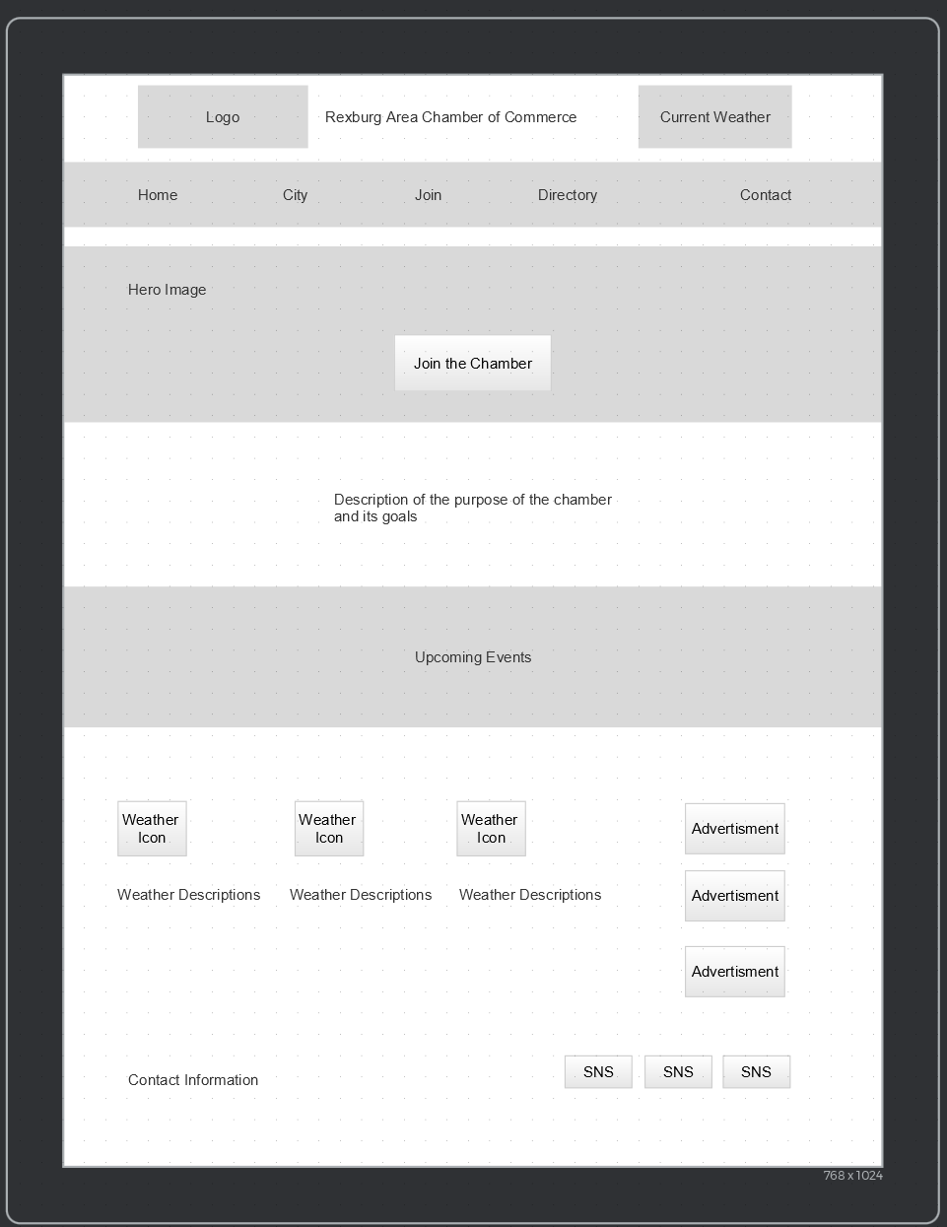

Large View (Desktop View)

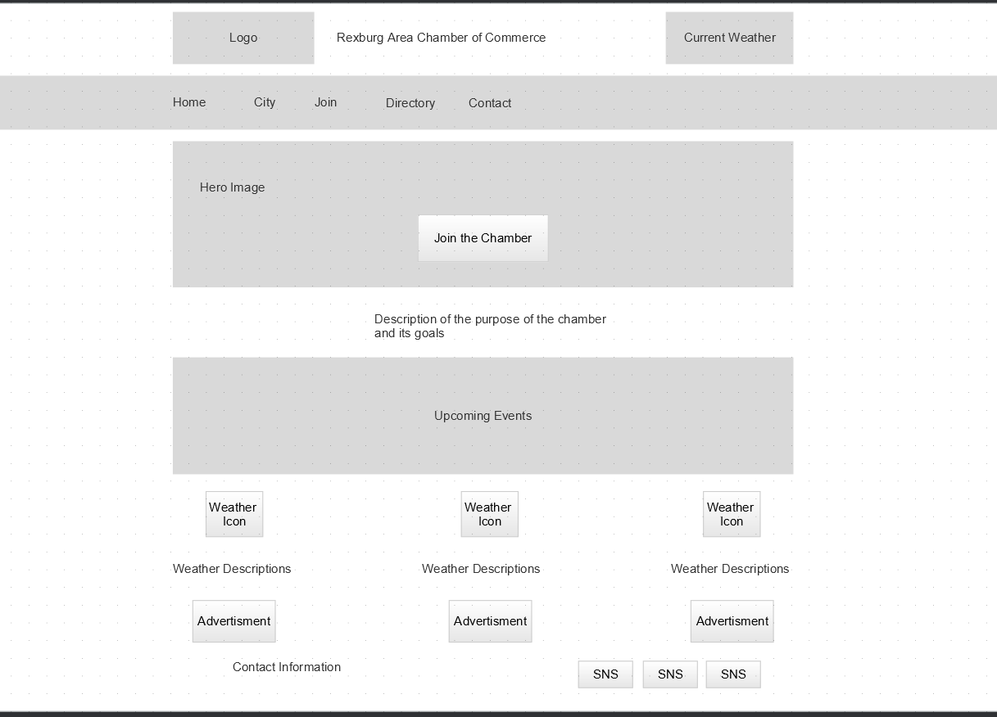

**Attribution Page:**

* Hero image - <https://www.rexburg.org/sites/default/files/styles/gallery500/public/imageattachments/services/page/10680/dji_0133.jpg?itok=GEGJyJMO>
* https://unsplash.com/photos/7RWBSYA9Rro
* Home page Hero image - <https://www.rexburg.org/sites/default/files/styles/full_node_primary_extra_wide/public/imageattachments/community/page/7891/rexburg.jpg?itok=FO8J2u_j>
* Hero image – <https://explorerexburg.com/wp-content/uploads/sites/11/2017/07/Rexburg-Cityscape1.jpg>
* Join page Hero image - <https://unsplash.com/photos/376KN_ISplE>
* Contact Hero image - https://www.pexels.com/photo/man-people-woman-desk-7658369/
* Weather icons - <https://uiplanet.blogspot.com/2021/05/get-3d-weather-icons-for-adobe-xd-figma.html>
* Mountain logo - <https://icons8.com/icon/3CdGadNlwBQD/snow-capped-mountain>
* Join Now image - <a href="https://www.vecteezy.com/free-vector/join-us">Join Us Vectors by Vecteezy</a>
* Thumbnail for a tour video - <https://www.flickr.com/photos/courthouselover/7648263582>
* Tour video - [https://www.elocallink.tv/m/v/player.php?pid=w1aAB2x3&fp=idrexb18_wel_rev1_iwd#](https://www.elocallink.tv/m/v/player.php?pid=w1aAB2x3&fp=idrexb18_wel_rev1_iwd)
* Current event info - <https://www.rexburg.org/calendar/month/2021-08>
* Thank you-picture - https://unsplash.com/photos/zunGugEsJCE

City history

* <https://www.rexburg.org/community/page/history>

City info

* Census 2020 - <https://worldpopulationreview.com/us-cities/rexburg-id-population>
* http://censusviewer.com/city/ID/Rexburg

Rexburg pictures

* <https://www.eastidahonews.com/2020/03/rexburg-temple-closes-due-to-covid-19/>
* <https://www.postregister.com/news/local/money-to-be-made-in-madison-county-rexburg-is-increasingly-an-attractive-place-to-do/article_47c011af-85c6-560e-b723-fe5b4c7a1544.html>
* <https://www.rexburg.org/sites/default/files/styles/full_node_primary_extra_wide/public/imageattachments/area-info/page/8891/tetons_-_t.jpg?itok=mD4iiGIw>
* https://blog.pathwaynewsroom.org/wp-content/uploads/2017/03/Campus-Aerial-1000x400-1488831859.jpg

Business icons

* Madison Library: <https://madisonlib.org/wp-content/uploads/2017/02/New-Logo-full-location-blue-1.png>
* ABRI Associates, LLC: <https://liveabri.com/wp-content/uploads/2017/03/abri-logo.png>
* A-1 Rental In. : <https://a1rental.net/images/logo.png>
* 0500 MECHANICS: <https://www.0500mechanics.com/Files/Images/logo.svg>
* Fisher’s Technology: <https://cdn-bpinh.nitrocdn.com/YWkCVMeHSYvadEAtuJPpVWeqyyXTrziG/assets/static/optimized/rev-7ba31b4/wp-content/uploads/2017/09/Fishers-logo-300px@2x-250x93.png>
* Gravity Factory: <https://www.gravityfactory.net/wp-content/themes/jump/graphics/gravity-factory-logo.png>

SNS Logo

<http://www.pixeden.com/social-icons/psd-flat-social-icons>

Grid & list view logo

<https://www.iconfinder.com/search/?q=grid>

https://thenounproject.com/search/?q=list+view&i=3647997